Care Control February 2020

Fundraising, Falls Risks and Other Fixes

Contents
Introduction by Matt Luckham 3
Systems Versions 3
Staff Files Integrity Checks 3
Health Check Score 3
Falls Risk Assessment Amendments 4
New V-Book System Settings 5
Add Service User Note 5
Staff Member Linked to Note 5
New Alert 6
Fundraising 7
Bugs Fixed 8

Introduction by Matt Luckham
Following the large update we released at the beginning of January, this is a smaller update containing some small improvements and bug fixes.

Systems Versions
After this update you should be using Care Control Windows version 3.30 or higher and Care Control Mobile 4.34 or higher.

Staff Files Integrity Checks
We introduced this feature in the January release. We have added a new check to ensure that all active staff members have a staff photo.

Health Check Score
We have added a new Health Check Score value based on Staff File Integrity. The details are: -
18. No. Staff File Integrity Errors Per Staff Member
This measure is the number of Staff File Integrity Errors per active primary staff member. This has a weighting of 1.5 with the maximum score of 30 points.
< 2 = 20 Points
< 3 = 15 Points
< 4 = 10 Points
<5 = 5 Points
This puts the maximum score for Health Check that you can now achieve to be 760 points.
Please note – with this release ALL Health Check Scores will be affected by this new measure.

Falls Risk Assessment Amendments
We have updated the Falls Risk Assessments on CC Windows. The updated Risk Assessment now includes a Mitigating Areas section which allows you to enter a free text mitigating reason and a score. This is then used in the overall score.
This section is at the bottom of the Risk Assessment: -
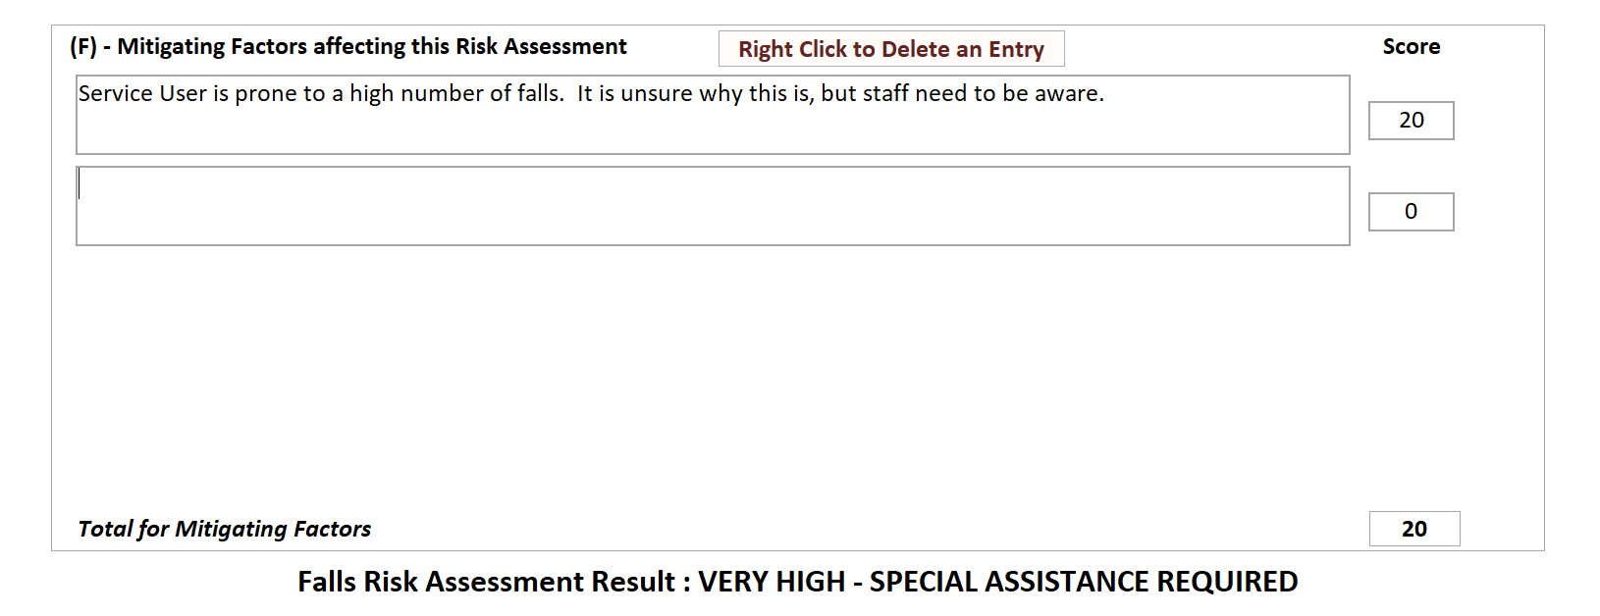
Any score that is entered in here is added into the overall total.

New V-Book System Settings
We have added two new V-Book settings which are accessible via the V-Book screen: -
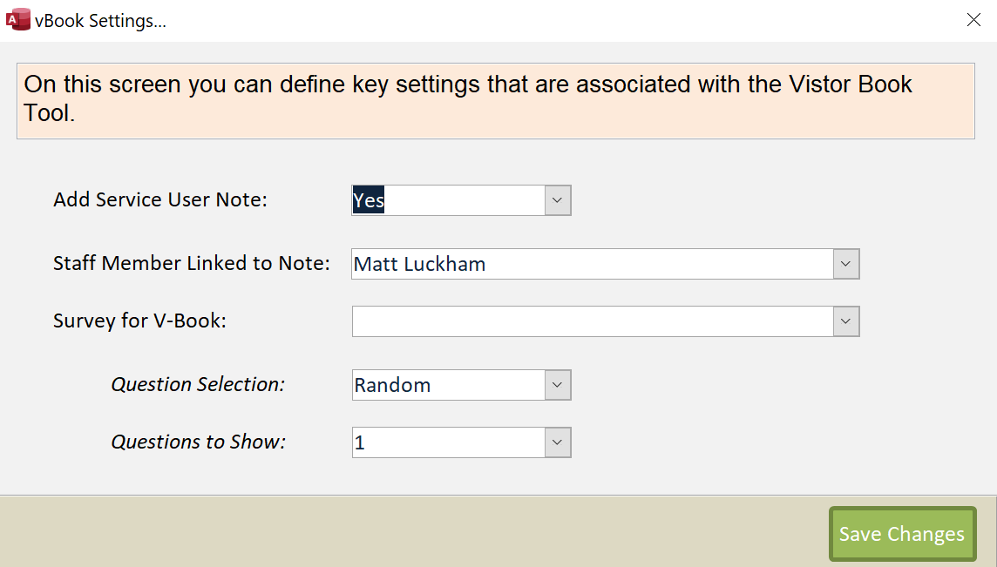

Add Service User Note
Use this setting to toggle if a note is added to the Care Plan System.

Staff Member Linked to Note
When a note is added from V-Book we need to attach the note to a staff member. Select a staff member from this list.

New Alert
We have added a new Alert: -
Alert when a specific word is entered in a note, but another word is not entered.
With this Alert you can enter a word to match against and a word to exclude. For example, you could enter: -
Alert me when the word “fall” is recorded in a note, but the words “falls risk” is not included.

Fundraising
We have added a new Fundraising area to record funds being generated by the home. You can click on this in the Communication area: -
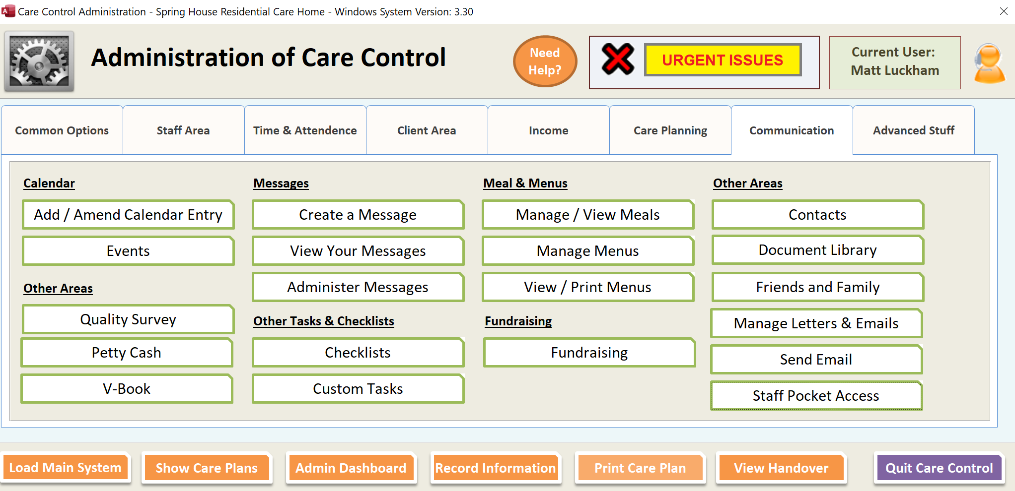
This area allows for easy access to a Fundraising area: -
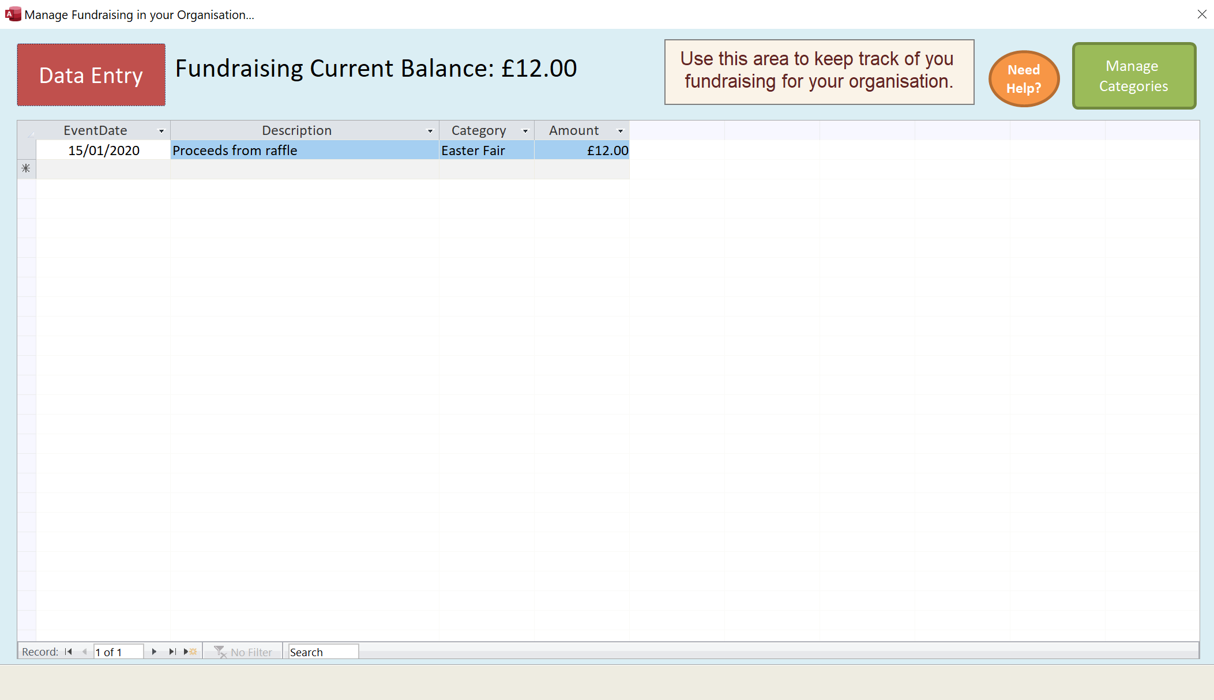
You can use this area to store information about money raised by events held to support the service users.

Bugs Fixed
A number of other bugs have been addressed in this update: -
System | Area | Bug
CC Mobile | Food Intake | Fixed in 4.34 – issue with screen not allowing multiple entries to be added.
CC Mobile | Food Intake | Fixed in 4.34 – issue that menu choice was not being brought through onto screen.
CC Windows | Payroll | Issues change the shift indicators, weekday and date rates.
CC Windows | Messaging | When in staff mode, box appears to ask for parameter V.

